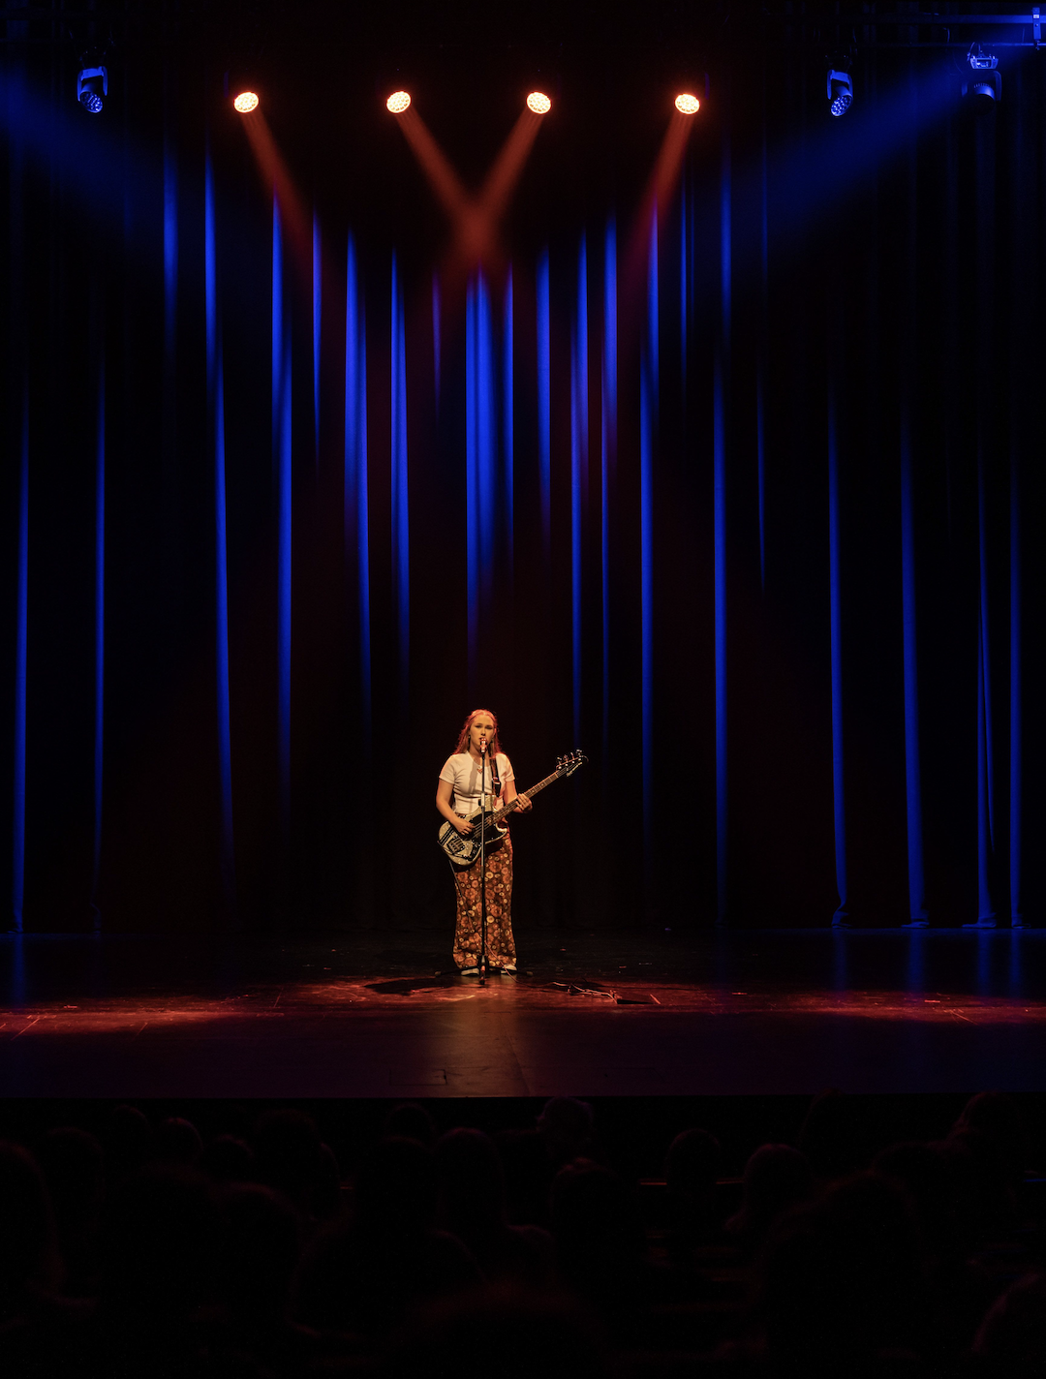

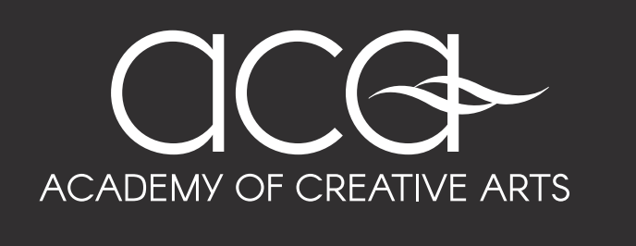

APPLICANT INFORMATION PACK

Program

VISION

‘Our Academy provides developing student-artists with unique educational opportunities, connected to leading professional artists and arts educators within a carefully cultivated environment and curriculum to leverage the resultant advantages to their developing minds, bodies and lives’

VALUES

Readiness: Academy student-artists are always well prepared to be coached, perform and represent

Resourcefulness: Academy student-artists are equipped with the skills and self-esteem to achieve the best-case outcome in all situations

Resilience: Academy student-artists understand that failure is a necessary part of artist development and treat it as an opportunity to learn

Reflectiveness: Academy student-artists are self-aware and understand that reflection is a valuable tool in individual growth

Reciprocity: Academy student-artists understand that they belong to a global community and their contribution to it is a direct reflection of who they are

ETHOS

Our academy is driven by a fundamental desire to cultivate the best young minds and bodies possible. Shaped and focused within mediums they love, student-artists develop the confidence to engage with the wider world, peers and industry.

Alongside our belief in the profound long-term benefits to our student-artists in developing their creativity and skills in their chosen field of focus, we rejoice in and strive to maintain the comprehensive gains our students enjoy in overcoming issues of attendance, engagement, mental health and social interaction in their daily lives.

Academy of Creative Arts – WHAT IS IT?

The Academy of Creative Arts (ACA) is an audition entry specialist Arts Academy designed to help student-artists pursue excellence in their chosen field. The Academy offers successful auditionees access to specialist extracurricular coaching from leading industry professionals, alongside timetabled collaborative arts classes. Within this model they receive a truly unique opportunity to hone their creative output and capacity alongside their traditional educational input.

The Academy also provides students with a tight knit community that allows them to feel supported and encouraged in their creative pursuits. The nature of the program encourages students to develop positive personal attributes such as curiosity and confidence, determination and drive, resilience and reliability. And, well, it’s a lot of fun.

Key Components of the ACA

- Professionally led, vocationally specific instruction
- Cultivated boutique performances and presentation opportunities
- Purpose driven and delivered project based curriculum
- Artist Educator led Masterclass critique and peer analysis
- Exposure to elite performers, creatives, visiting artists and arts education providers
- Collaborative peer engagement and cooperation within timetabled sessions

INCLUSIONS
- 2 x Timetabled Artist Development Classes
- 4.5 hours of Technical Field Coaching sessions
- Before school breakfast supplements after early morning session
- ACA t-shirt
- Some excursions, workshops and performances

COST 2024 (2025 TBC)
$1,300

KEY DATES

Applications Close – Monday 9th of September 2024
Audition Notifications – Friday 13th of September 2024
Auditions – 28th & 29th September 2024 (TBC)
Audition Results – Week of 7th of October 2024 (TBC)
Fee Deadline – Friday 7th of February 2024 (Payment Plan available on request)

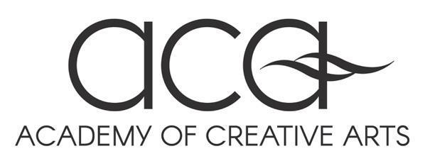
ACA | 2024 AUDITION REQUIREMENTS
BAND
Prepare two contrasting pieces of no more than ten minutes. - Prepare two major and two minor scales and arpeggios. - A piano, drum kit and amplifier are available for use. Applicants must provide their own accompanist or backing tracks if the works require them.
DRAMA
Prepare two contrasting monologues from the ACA Monologue Booklet. Wear comfortable clothes that are easy to move in.
DANCE
All applicants will partake in a group audition with the opportunity to present a solo afterwards. Wear comfortable clothes that are easy to move in.

VOCAL
Prepare two contrasting songs of 2-3 minutes each. Prepare two major scales. Applicants must provide their own accompanist or backing tracks - without lead vocals - if the works require them.
VISUAL ARTS
Prepare a portfolio of your work. We suggest that you supply at least 10 pieces as an absolute minimum (the more you provide the better chance you have of gaining admission). The more mediums that you can show, the better. Inclusion of sketches and digital work is also encouraged. Unfinished work is acceptable as it displays the progression of your skills.
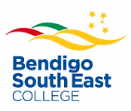
‘Strive for Excellence’

TESTIMONIALS

EXTERNAL

“Just a short note to thank you for the opportunity to work with you and your students at B.S.E.
I thoroughly enjoyed working with these students, they were some of the best young people I’ve had the pleasure of working with.
The unique ACA program you have at BSE is certainly offering wonderful opportunities to young regional Victorians to develop and showcase their talents.
This was evident when I attended the concert last year, I was amazed by the talent, enthusiasm, the performances and the commitment of the students and the staff.
These achievements are clearly a testament to your program and I congratulate all concerned.
I hope this wonderful program continues to offer these, and other students in the future this wonderful exposure to performance and music and the opportunities to explore them further.”
Venetta Fields: Professional Vocalist and Educator

PAST STUDENT (Alumni)

"As an alumnus of the ACA program who has covered three of the five different fields the program offers, I can say without a doubt that the program was a gigantic impact on me throughout my years as a BSE student. It is the core reason I developed a strong work ethic which not only is used to pursue my passions but has carried over to my studies for VCE. It was my favourite subject in terms of self-directed learning, as I got to stick my head down and passionately research the history and global impact my fields had on the world. I always felt it was the most supportive and welcoming part of the college and I was never afraid to push myself into the environment which led to better confidence and polishing up my skillset. It was also a big factor in shaping my identity in high school - which is such a big deal when you are traveling through years 7 - 10. My life has only benefited from being a participant of the ACA program and I would recommend it to every student with an interest in any sorts of arts."

PARENT

“Stepping up to the challenge to audition and then be accepted to join an artistic community of high expectations has been a life affirming experience for my daughter.
As a passionate dancer and young woman who continually seeks opportunities to learn, the ACA has provided the extension and also the safe and creative community she has longed to connect with. ACA gives my daughter a community to thrive within, and has supported her to mature and turn her back on her friendship groups caught up in bullying and negative behaviour.”
Parent of Dance ACA Step-up student

“The Academy of Creative Arts (ACA) program was a key factor in our family choosing Bendigo South East College for each of our daughters’ secondary education.
The ACA program has offered our children outstanding learning experiences that have inspired them as artists and empowered them as people. Our daughters have expanded their performance skills and refined their individual talents. This program has enabled them to connect with likeminded people whilst expressing themselves in a way that is totally unique to them. The high-quality teachers that ACA boasts have challenged our children to do more, think more and be more than they ever could have imagined prior to this exposure. The growth in each of our daughters’ skillsets and mindsets since enrolment in this program, has been awe-inspiring and directly related to their coaches and the fruitful opportunities provided. It is such a wonderful testament to the school that such a quality Arts program is prioritised because it promotes the value of our children’s voices in a world that often dilutes them. Thank you, Bendigo South East College, for honoring the talents of tomorrows leaders, elite performers and professional artists.”
Parent of Year 8 Drama & Year 10 Vocal ACA students

CONTACT
Ellen-Kate Waayers Alysha Gourley
ACA Coordinator ACA Administration Support
ellen-kate.waayers@education.vic.gov.au aca@bse.vic.edu.au
03 5443 4522

