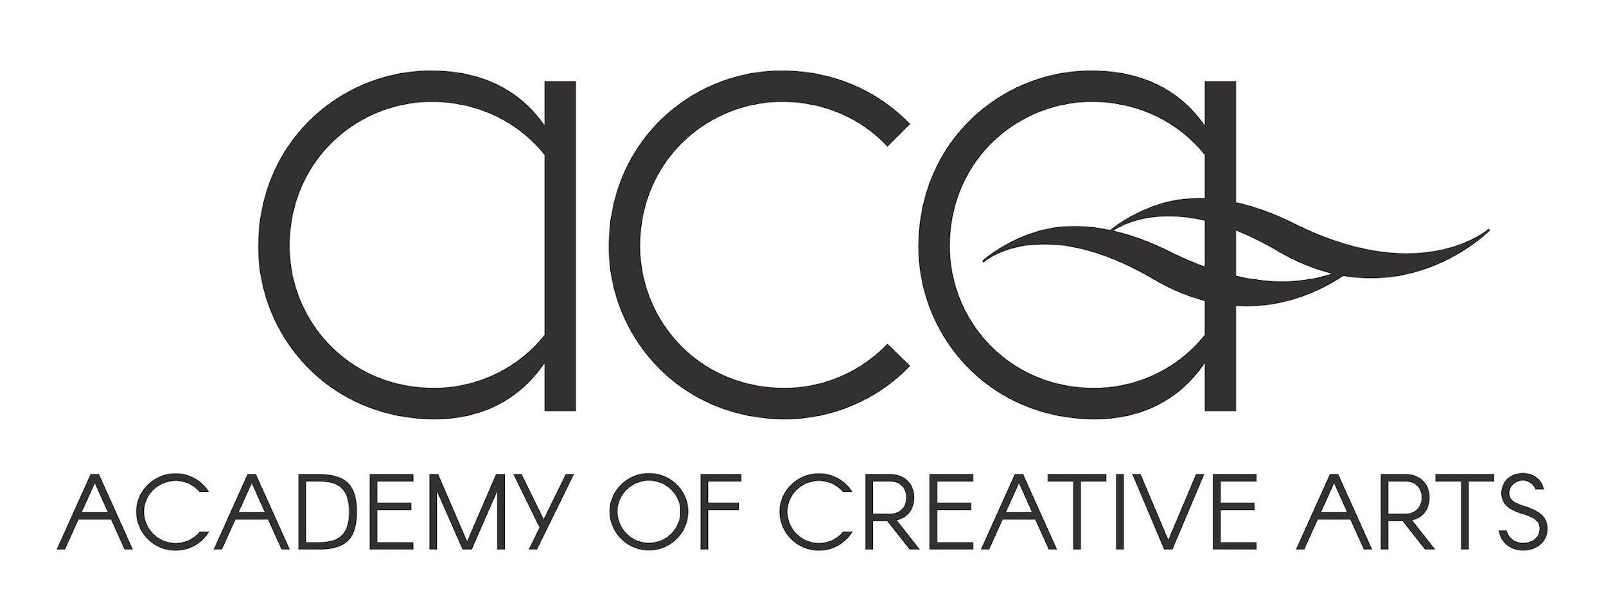

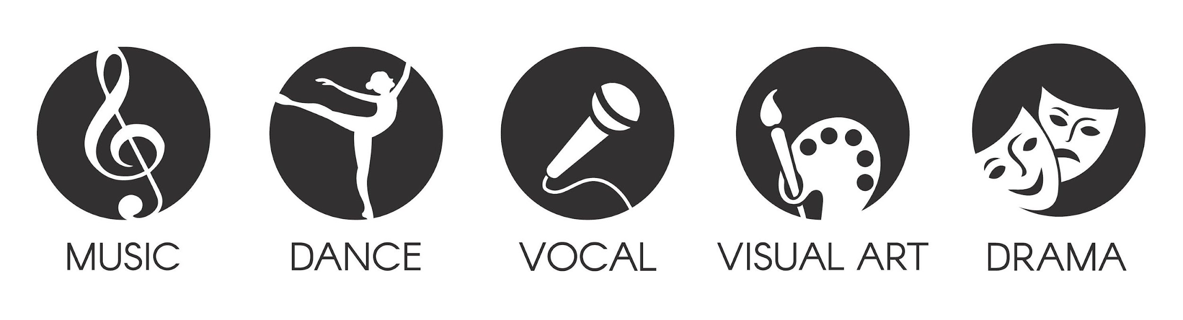
ACA Application Pack | 2024

‘Strive for Excellence’
Academy of Creative Arts
‘The Academy of Creative Arts aspires to teach, inspire and provide a pathway for
emerging creative artists to achieve artistic and academic excellence.’
The Academy of Creative Arts (ACA) provides experiences and opportunities to develop and guide aspiring artists. ACA focuses on mastering the skills of ‘creating, making and performing’. Students will be immersed in the world of an artist through direct tuition and the guidance of leading industry professionals.
ACA is a select entry program open to students from the ‘Step Up’ program in Year 6 to alumni in Years 11 and 12 and all the way through. Successful applicants will strive for excellence in a flexible and supportive academic learning environment.
AIM To provide flexible learning programs and support to develop high performing artists.
ASPECTS To provide specialist learning facilities and high performance workshops.
To provide contact with elite professionals as role models and mentors.
To provide access to competitions, excursions, trips and work experience opportunities.
To provide opportunities to perform/present to a wide range of audiences.
To provide the opportunity to establish a network for future vocation.
To provide access to industry quality equipment and resources.

ENROLMENT Acceptance into ACA means a commitment to the terms and conditions specified in the ‘Student ACA Agreement’. The agreement is to be signed by both student artist and a parent before commencement of the program.
APPLICATION Refer to the Admission Process Flowchart for details about the Application Process.
ANNUAL FEES As participation in the ACA is voluntary, not all costs will be covered in the College budget. Parents will be asked to contribute an annual fee. This annual fee of $1,300 (subject to change) contributes to costs associated with the program and must be paid before commencement of the program. This fee is non-refundable.
Some excursions will incur additional costs, especially where accommodation and transport are required. Parents will be given notice in advance of major excursions to assist with planning and budgeting.
Applications for the Holsworth Creative Arts Bursary are available for students of the Academy of Creative Arts to apply in 2023.
The total value of the scholarship pool is valued at, but not limited to, $2000 and will be distributed between one or more applicants at the absolute discretion of the deliberating panel.
IMPORTANT: Acceptance into the ACA in one year does not lead to automatic acceptance in the following year. Students are required to apply each year. Both academic achievement and performance progress will be regularly reviewed throughout the year. Students are therefore required to consistently satisfy academic, Learning Culture and performance criteria in order to maintain their place in the ACA program.
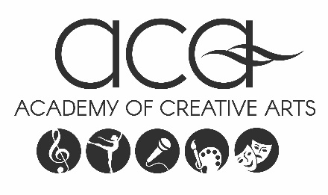

PERSONAL DETAILS

NAME

DATE OF BIRTH
YEAR LEVEL in
2024______

PARENT GUARDIAN NAMES

EMAIL ADDRESS PHONE

CHOSEN ART FIELD
BAND
DANCE VISUAL ARTS
DRAMA VOCAL

INSTRUMENT(S)

APPLICATION CONSENT
Please ensure all details are correct to the best of your knowledge and sign in the space below:

.............................................. ...........................................................................
Student Artist Name Student Artist Signature Date

.............................................. ...........................................................................
Parent Name Parent Signature Date

Late applications can be submitted and may b
CREATIVE DREAMS
PLEASE NOTE: The Selection Committee prefers applicants to complete this page in their own handwriting.
Please attach extra pages if you wish to supply more information.
Your Artistic Pursuits  Tell us about yourself as an artist and what you would like to achieve in your artistic pursuits, now and in the future. |  | Academic  What are your academic goals for 2024?

Describe how you imagine the ACA might benefit you and your development. |  | Please outline your current weekly rehearsal /visual diary schedule. Please list any external lessons or classes that you have on a regular basis, including your teacher/school name.

CONFIDENTIAL REFERENCE FROM TEACHER/INSTRUCTOR/MENTOR

Name of Teacher/Instructor/Mentor:
Position/Relationship:

Contact Number:
Contact Email:
This reference is for:

Strengths

Recommendations

Practice Commitment

Attitude

PROGRAM ENTRY
To apply for selection:
Submit a complete application by due date
Meet the selection criteria
Attend audition(s) and selection interviews as required
Band: prepare two contrasting songs
Dance: group audition with option to prepare solo work
Drama: prepare two contrasting monologues (see monologue booklet)
Visual Arts: put together a folio of some of your works
Vocal: prepare two contrasting songs

Note: All artists selected into the ACA are required to represent the program in their chosen field in various activities throughout the year including community performances and exhibitions

CHECKLIST
Please ensure that:
You have read and understood the terms and conditions of the program.
You and your parent/guardian have signed the application.
You have included your previous year’s school report.
You have supplied a Confidential Reference completed by your Referee.
SUBMITTING YOUR APPLICATION
Please return to:
ACA Office
Bendigo South East College
P.O Box 15, Strathdale
Victoria 3550

ADMISSION ENQUIRIES

ACA Admin Support
Bendigo South East College
Phone: 5443 4522
Email: aca@bse.vic.edu.au
Web: www.bse.vic.edu.au/excellence/aca

Please Return To: ACA Admin Support Email: aca@bse.vic.edu.au

